***HR EMPLOYEE ATTRITION ANALYSIS***

# **The domain of the Project:**

# SQL and Power BI

# **Mr. Sravan Nemana (and their designation):**

# **Team Members:**

Ms. Neeha Krishna

# **Period of the project**

# **June 2025 to December 2025**

Declaration

The project titled “HR Employee Attrition Analysis” has been mentored by Mr. Sravan Nemana, organised by SURE Trust, from June 2025 to December 2025, for the benefit of the educated unemployed rural youth for gaining hands-on experience in working on industry relevant projects that would take them closer to the prospective employer. I declare that to the best of my knowledge the members of the team mentioned below, have worked on it successfully and enhanced their practical knowledge in the domain.

Team Members:

Ms. Neeha Krishna Signature

N. Sravan

Designation—Company Name

Prof. Radhakumari

Executive Director & Founder

SURE Trust

Table of contents

1. Executive summary
2. Introduction
3. Project Objectives
4. Methodology & Results
5. Social / Industry relevance of the project
6. Learning & Reflection
7. Future Scope & Conclusion

***Executive Summary***

**Project Objective**

The objective of this project is to analyze employee attrition patterns and identify the key factors influencing workforce turnover. The goal is to provide actionable insights that help organizations improve employee retention, satisfaction, and overall workforce stability.

**Methodology**

* Used the **IBM Employee Attrition dataset** to analyze demographic, job-related, and compensation factors.
* Performed exploratory data analysis using **Power BI**.
* Key metrics analyzed include **attrition rate, salary, job satisfaction, overtime, tenure, age group, and job role**.
* Interactive dashboards were built to enable **drill-down analysis** across departments, roles, and age groups.

**Key Findings**

* The overall **attrition rate is 16.1%**, indicating moderate employee turnover.
* Employees working **overtime** show significantly higher attrition, highlighting workload-related stress.
* **Low salary bands** experience the highest attrition, with attrition decreasing as compensation increases.
* **Sales Representatives** and **Laboratory Technicians** have the highest turnover rates among job roles.
* The **18–25 age group** shows the highest attrition, suggesting early-career job switching.
* Lower **job satisfaction levels** strongly correlate with increased attrition.

**Recommendations**

* Review compensation structures, especially for **low-salary and high-attrition roles**.
* Reduce excessive overtime by improving workload distribution and staffing.
* Implement targeted engagement and retention programs for **young and early-career employees**.
* Focus on improving job satisfaction through better career growth opportunities, recognition, and work-life balance initiatives.
* Conduct role-specific retention strategies for high-risk positions such as sales roles.

**Business Impact**

By addressing the identified drivers of attrition, organizations can:

* Reduce recruitment and training costs
* Improve employee morale and productivity
* Build a more stable and engaged workforce

***Introduction***

**🔹 Project Background & Context**

Employee attrition is a critical challenge for organizations, leading to increased recruitment costs, loss of skilled talent, and reduced productivity. Understanding why employees leave and identifying high-risk groups is essential for building effective retention strategies.  
This project uses data analytics and visualization to explore workforce trends and uncover the key factors driving employee turnover.

**🔹 Problem Statement & Project Goals**

Organizations often struggle to pinpoint the exact reasons behind employee attrition due to the complexity of workforce data.  
The goal of this project is to:

* Analyze employee attrition patterns using historical HR data.
* Identify key factors influencing employee turnover.
* Present insights through an interactive Power BI dashboard that supports data-driven HR decisions.

**🔹 Scope of the Project**

* Analysis is based on the **IBM Employee Attrition dataset**.
* Focus areas include:
  + Demographics (age group, department)
  + Job-related factors (job role, overtime, tenure)
  + Compensation and satisfaction metrics
* Interactive dashboards allow filtering by department, age group, job role, and salary band.
* The project is designed for **exploratory analysis and strategic insights**, not predictive modeling.

**🔹 Limitations of the Project**

* The dataset represents a **single organization** and may not generalize across industries.
* Analysis is **descriptive**, not predictive (no machine learning models used).
* External factors such as economic conditions and personal reasons for attrition are not included.
* Data quality depends on the accuracy and completeness of the original dataset.

**🔹 Innovation Component**

* Designed a **clean, executive-friendly Power BI dashboard** focusing only on high-impact KPIs.
* Integrated **business storytelling** by highlighting key insights and recommendations directly on the dashboard.
* Enabled **interactive exploration** using slicers for deeper HR analysis.
* Converted raw HR data into actionable insights that can directly influence workforce planning and retention strategies.

***Project Objectives***

**🔹 Project Objectives**

* To analyze employee attrition trends using structured HR data.
* To identify key factors influencing employee turnover such as job role, age group, salary band, overtime, and job satisfaction.
* To visualize workforce insights through an interactive and intuitive Power BI dashboard.
* To support HR teams and management in making data-driven decisions to improve employee retention.

**🔹 Expected Outcomes & Deliverables**

* A **fully interactive Power BI dashboard** highlighting key attrition metrics and patterns.
* Clear identification of **high-risk employee segments** prone to attrition.
* Actionable insights that help organizations:
  + Improve retention strategies
  + Optimize compensation and workload policies
  + Enhance employee satisfaction
* A **PDF-exportable dashboard** suitable for executive presentations and reports.
* A structured dataset understanding and visual documentation for future analysis or enhancements.

***Methodology and Results***

**🔹 Methods / Technology Used**

* **Exploratory Data Analysis (EDA)** to understand data distribution, patterns, and anomalies.
* **Data cleaning and preprocessing** to handle missing values, categorical encoding, and derived metrics.
* **Descriptive analytics** to calculate key KPIs such as attrition rate, average tenure, salary trends, and satisfaction index.
* **Comparative analysis** across employee attributes (job role, age group, salary band, overtime, job satisfaction).
* **Data visualization techniques** to present insights clearly and support decision-making.

**🔹 Tools / Software Used**

* **Power BI** – Dashboard creation, interactive visualizations, slicers, and PDF export.
* **Microsoft Excel / CSV files** – Data storage and initial inspection.
* **Power Query (Power BI)** – Data transformation and preprocessing.
* **DAX (Data Analysis Expressions)** – Calculation of measures and KPIs.
* **Microsoft PowerPoint** – Project presentation and documentation.

**🔹 Data Collection Approach**

* Used a **secondary dataset** (IBM Employee Attrition Dataset).
* Dataset contains anonymized employee information such as:
  + Age, job role, department
  + Salary details and overtime
  + Job satisfaction and tenure
  + Attrition status
* Data was **pre-collected and publicly available**, requiring no direct surveys or experiments.

* Final project working screenshots along with supporting explanation

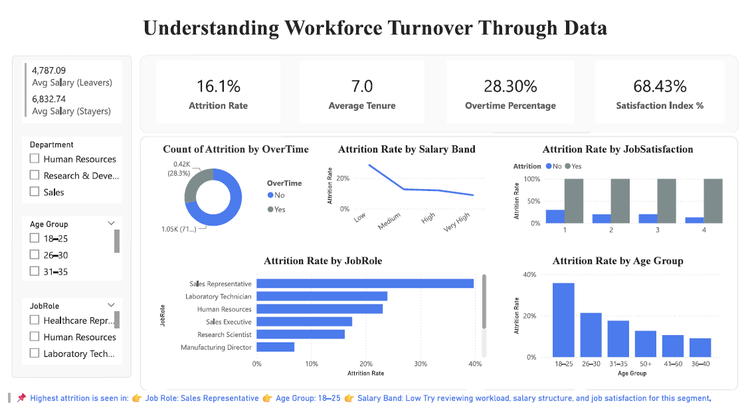

**Final Project Working – Dashboard Explanation**

The screenshot above represents the **final interactive dashboard** developed for the **Employee Attrition Analysis** project. The dashboard provides a comprehensive overview of workforce turnover patterns using multiple KPIs, filters, and visualizations.

**Key Performance Indicators (Top Section)**

* **Attrition Rate (16.1%)**  
  Displays the overall percentage of employees who have left the organization.
* **Average Tenure (7.0 years)**  
  Indicates the average number of years employees stay with the company.
* **Overtime Percentage (28.30%)**  
  Shows the proportion of employees working overtime, helping analyze workload impact.
* **Satisfaction Index (68.43%)**  
  Represents the overall job satisfaction level of employees.
* **Average Salary (Leavers vs Stayers)**  
  Compares the average salary of employees who left versus those who stayed, highlighting compensation-related attrition trends.

**Interactive Filters (Left Panel)**

* **Department**
* **Age Group**
* **Job Role**

These slicers allow users to dynamically filter the dashboard and analyze attrition trends across specific employee segments.

**Visual Insights (Main Section)**

* **Count of Attrition by Overtime (Donut Chart)**  
  Shows the distribution of attrition between employees who worked overtime and those who did not.
* **Attrition Rate by Salary Band (Line Chart)**  
  Illustrates how attrition varies across salary levels, showing higher attrition in lower salary bands.
* **Attrition Rate by Job Satisfaction (Stacked Bar Chart)**  
  Compares attrition between satisfied and dissatisfied employees, highlighting the relationship between satisfaction and retention.
* **Attrition Rate by Job Role (Horizontal Bar Chart)**  
  Identifies job roles with the highest attrition, with Sales Representatives showing the highest rate.
* **Attrition Rate by Age Group (Column Chart)**  
  Displays age-based attrition trends, indicating higher attrition among younger employees (18–25 age group).

**Key Insight Summary (Footer)**

The dashboard highlights that **attrition is highest among Sales Representatives, employees aged 18–25, and those in lower salary bands**, suggesting a need to review workload, compensation structure, and job satisfaction for these segments.

* Project GitHub Link

[Link](https://github.com/neehakrishna26/HR-Employee-Attrition-)

***Learning and Reflection***

**👤 Team Member : Neeha Krishna**

**📘 New Learnings**

**Technical Learnings**

* Gained hands-on experience in **Power BI dashboard development**, including KPI design and interactive visualizations.
* Learned to use **Power Query** for data cleaning, transformation, and creation of derived columns such as Age Group and Salary Band.
* Developed proficiency in **DAX** to calculate business metrics like attrition rate, average tenure, overtime percentage, and satisfaction index.
* Understood how to apply **data visualization best practices** for executive-level dashboards (minimal KPIs, color coding, layout structuring).

**Analytical & Domain Learnings**

* Learned how HR data can be used to identify **employee retention risks**.
* Gained insights into how factors like **salary, job satisfaction, overtime, and age** influence attrition.
* Improved ability to translate raw data into **actionable business insights**.

**Management & Soft Skills**

* Improved **project planning and task structuring** by defining objectives, scope, and deliverables.
* Enhanced **presentation and storytelling skills** while explaining insights to a non-technical audience.
* Developed better **time management** while balancing dashboard building, documentation, and presentation preparation.

**🌱 Overall Experience**

Working on this project was a valuable learning experience that strengthened both technical and analytical skills. The project provided practical exposure to real-world HR analytics and helped bridge the gap between raw data and business decision-making. Designing an end-to-end solution—from data understanding to dashboard presentation—improved confidence in handling analytics projects independently. Overall, the project enhanced problem-solving ability, attention to detail, and professional communication skills.

***Conclusion and Future Scope***

**🔹 Conclusion**

**Recap of Objectives & Achievements**

The primary objective of this project was to analyze employee attrition patterns and identify the key factors contributing to workforce turnover. This was successfully achieved by exploring HR data and building an interactive Power BI dashboard that highlights attrition trends across age groups, job roles, salary bands, overtime, and job satisfaction levels.

The project delivered meaningful insights, including the identification of high-risk employee segments and the relationship between attrition and factors such as compensation, workload, and satisfaction. By transforming raw data into structured KPIs and visual insights, the project demonstrates how data analytics can support informed HR decision-making.

**Future Scope of the Project**

* Integrate **predictive analytics or machine learning models** to forecast attrition risk for individual employees.
* Expand the dataset by including **real-time or multi-company HR data** for broader applicability.
* Incorporate additional factors such as performance ratings, training history, and promotion timelines.
* Develop role-specific **retention recommendation systems** based on identified attrition drivers.
* Deploy the dashboard as a **web-based or cloud-hosted BI solution** for continuous monitoring.